Лекция 3
- Числовая характеристика среднего
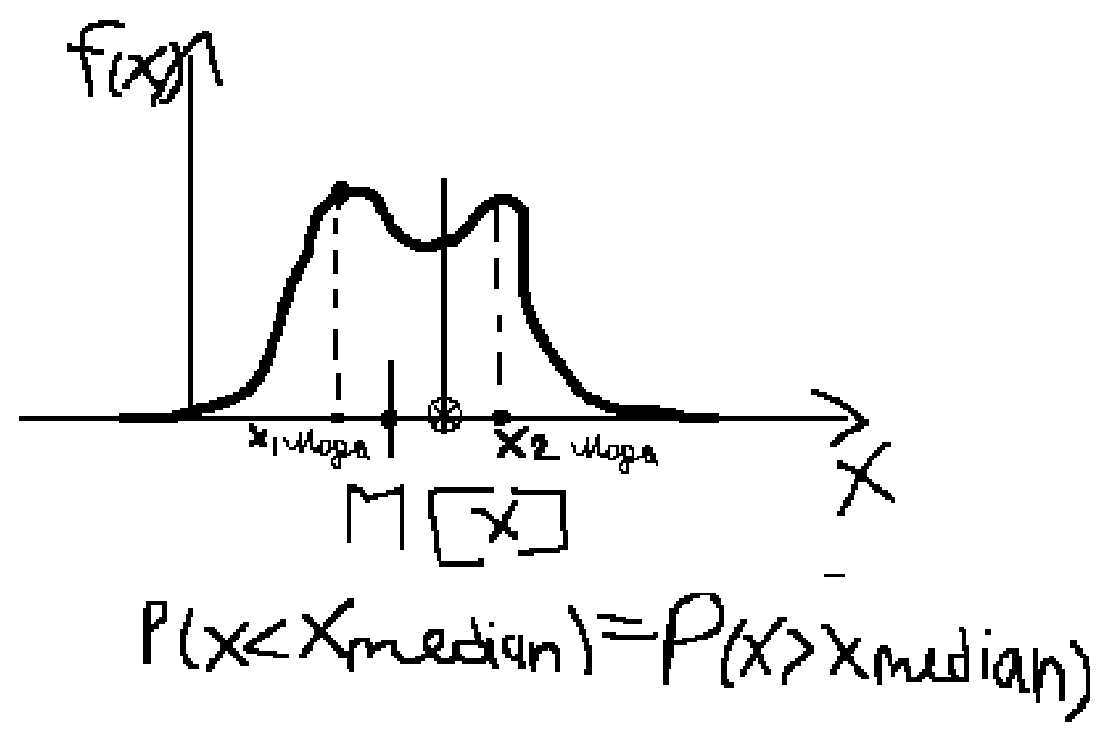
M[x] = ∫(-∞,+∞)xf(x)dx = Σ(i)xipi

1) M(c) = c
2) M[x+c] = Σ(xi+c)pi = M[x] + c
3) M[x-M[x]] = Σxi + Σcpi = M[x] + c Σpi
4) M[cx] = cM[x]
Mo = x_{мода}
Ме = x_{median}
30 | 30 | 30 | 30 | 30 | 30 | 60 | 60
6 чел |  |  |  |  |  | 2 чел

x | 30 | 60
P(x) | 6/8 | 2/8

30*6/8+60*2/8=37.5=M[x]
Mo=30
Me=30
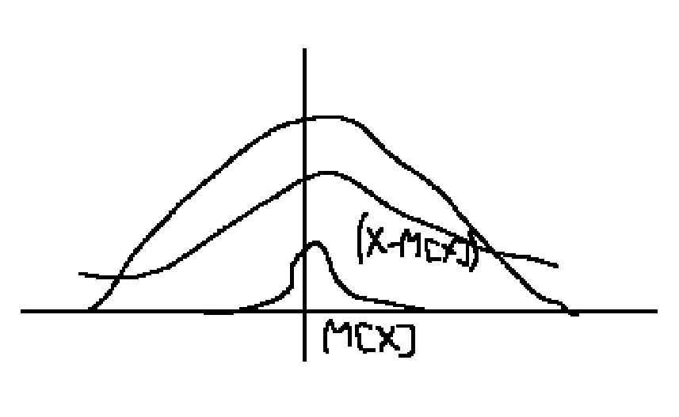
D[x] = M[(M[x]-x)²] = M[(x-M[x])²]
σ[x]=(D[x])^{1/2}
D[x] = Σ_{(i=1,n)}(xi-M[x])²pi = ∫_{(-∞;+∞)}(x-M[x])²f(x)dx
- D(c) = 0
- D[_{c}x]=c²D[x]
D[_{c}x] = Σ(cxi-M[cx])²pi = c² Σi(xi-M[xi])²pi
- D[x] = M[x²] = M[x]²
Mk[x] = dk = M[x^{k}]
M1[x] = d1 = M[x]
Bk = M[(x-M[x])^{k}]
B1 = 0
B2 = D[x]
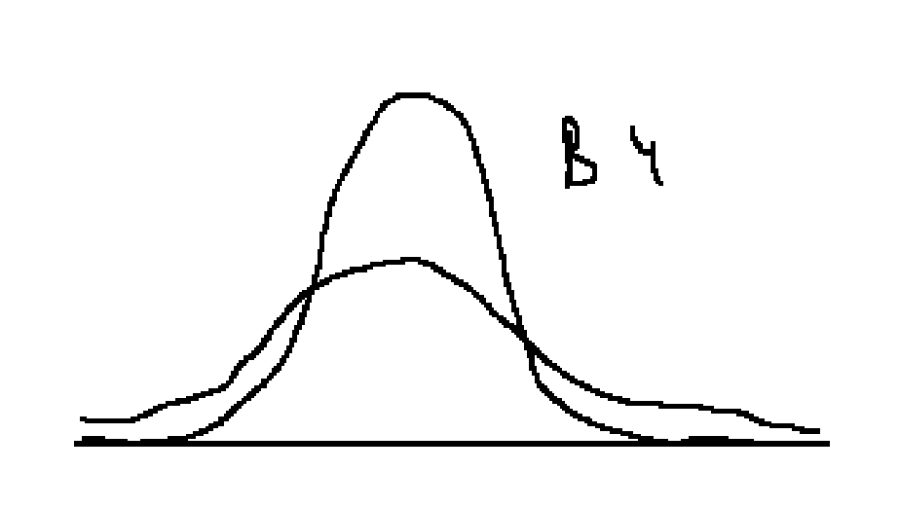
P(x<xq) = F(q)
xq = квантиль q = дано

